End of financial year (EOFY) is a great time to make the most of the tax-deductible status of donations made via the Fundraise Yourself platform. All donations, over $2, made by your supporters is tax-deductible. This is a great incentive for community members and businesses to receive a tax break when they complete their tax return for the 2019/20 financial year. Spread the word by using our templates below.
Social Media
Social media platforms are a powerful way to communicate with your school community and provide them with the opportunity of tax-deductible donations.
- Facebook Template 1:
When to post: Between 10 June to 17 June 2020
[Start post]
Did you know that all donations over $2 to <Insert School Name> made via the link below are tax-deductible? With tax-time just around the corner, today is your opportunity to make a difference in the lives of our students. Your donation will go towards our <Insert Project Name>.
<Insert your Schools Plus Fundraise Yourself URL>
[End Post]
- Facebook Template 2:
When to post: Between 18 June & 30 June
[Start post]
We’re just days from the end of the financial year. Don’t miss your opportunity to support <Insert School Name> students and receive a tax-deductible receipt for donations over $2, made via the link below! Your contribution will fund our <Insert Project Name> .
<Insert your Schools Plus Fundraise Yourself URL>
[End post]

Here are some examples of how schools utilised Facebook to bring in additional donations last EOFY:
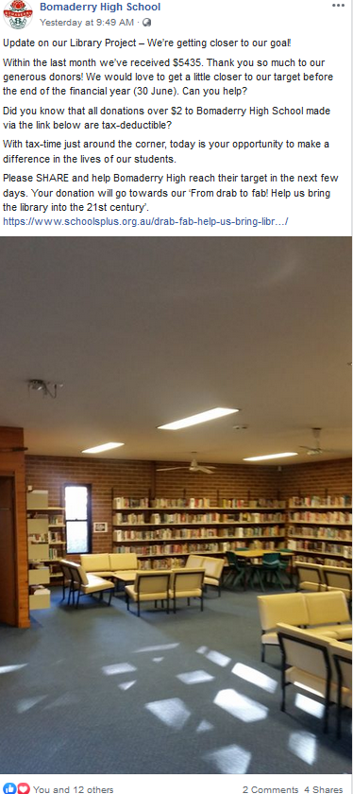

Tax-time Email Template
When to send: Between today & 30 June

Subject line: Did you know you can make a tax-deductible donation to <Insert School Name>
[Start email]
Dear <Recipient Name>,
Please allow me to introduce myself – my name is <Insert your name> and I’m a <Insert your title> at <Insert School Name>. I’m writing to you today because our students need your support.
<Insert Project Name> is about <Insert Short description of your project>. Our students and teachers would greatly benefit from this initiative so we’re working hard to make it a reality. But for this vision to come to life, we need your help.
Donating to <Insert School Name> is made easy through our connection with Schools Plus – a charity that connects Australian schools in need with generous donors. With the end of the financial year fast approaching, I thought you might like to know that all donations over $2 and made via our online fundraising page are tax-deductible: <Insert your Schools Plus Fundraise Yourself URL>
Here is how your generous donation can help our students:
- $<insert amount> helps to cover the cost of <Insert item>
- $<insert amount> helps to cover the cost of <Insert item>
- $<insert amount> helps to cover the cost of <Insert item>
Any support will be highly appreciated by our students and staff. If you have any questions, please feel free to contact me on <Insert phone number you are happy to share> or reply to this email. Thank you for time and consideration.
Sincerely,
<Insert your name>
<Insert your title & contact details>
[End email]

Notes:
- I highly recommend picking up the phone calling individuals you believe have the capacity to donate. You can use the email above as a draft for a call script when calling.
- Don’t forgot to follow up anyone you don’t hear from. Silence isn’t a no! If someone is interested in giving they will be thankful for a little nudge.
- Hand written letters are a nice way to stand out from the crowd.
- Don’t forget to thank and provide updates to your donors after they give!

Good luck

